## FONKAN FM-505 UHF RFID INTEGRATED MODULE DATASHEET

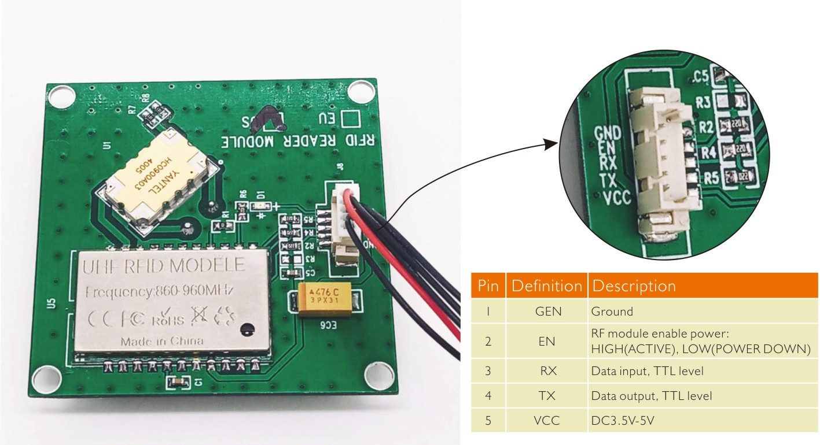

|  |  |  |  |
| --- | --- | --- | --- |
| **Specification** | | | |
| **Model No.FM-505** | | | |
| **Frequency** | 840-960MHZ | **Working Voltage** | DC 3.5V – 5 V |
| **Working area support** | US, Canada and other regions following U.S. FCC  Europe and other regions following ETSI EN 302 208  Mainland China; Japan; Korea; Malaysia; Taiwan | **PCB size** | Pcb size:40*40mm , Ceramic antenna size:50*50mm  Overall height:8.5mm |
| **Protocol** | EPC global UHF Class 1 Gen 2 / ISO 18000-6C | **Standby current** | <80mA (EN  pin high level) |
| **Output power** | 0-25 dBm | **Sleeping current** | <100uA (EN  pin low level) |
| **Read/write** | Read: 200-250cm;write: 10-50cm(adjusted) | **Operation current** | 180mA @ 3.5V (26 dBm Output,25°C).  110mA @ 3.5V (18 dBm Output,25°C). |
| **Output power accuracy** | +/- 1dB | **Operation temp.** | - 20 °C  -  + 70  °C |
| **Output power flatness** | +/- 0.2dB | **Storage temp.** | - 20 °C  -  + 85  °C |
| **Receive sensitivity** | < -70dBm | **Working humidity** | < 95% ( + 25 °C) |
| **Read tag peak speed** | > 50pcs/sec | **Communication interface** | TTL Uart interface |
| **Operating time** | <100mS. | **Heat-dissipating method** | Air cooling(no need for out install cooling fin) |
| **Communication baud rate** | 115200 bps(default and recommend)  38400bps |  |  |
|  |  |  |  |

## 1. ABSOLUTE MAXIMUM RATINGS

|  |  |  |
| --- | --- | --- |
| **Parameter** | **Symbol** | **Conditions** |
| **Max storage   temperature** | TSTOREmax | +120℃ |
| **Min storage   temperature** | TSTOREmin | -60℃ |
| **Power supply   voltage** | VIN | -0.1V   to +5.5V |
| **Electrostatic   discharge** | VESD | 1KV |

**2. Specification of RFID Reader**

#### ****2.1 Recommend operating conditions****

|  |  |  |  |  |  |
| --- | --- | --- | --- | --- | --- |
| **Par**  **meter** | **Symbol** | **Min.** | **Typ.** | **Max.** | **Unit** |
| **Power Supply   voltage** | **VIN** | **3.6** | **5** | **5.5** | **V** |
| **Operating   Temperature** | **Ta** | **0** | **-** | **+50** | **℃** |
| **Storage   Temperature** | **Ts** | **-25** | **-** | **+65** | **℃** |

## ****2.2 Electrical characteristics****

## ****2.2.1 DC characteristics (VIN =3.6V to 5V, VSS= 0V)****

|  |  |  |  |  |  |
| --- | --- | --- | --- | --- | --- |
| **Parameter** | **Symbol** | **Min.** | **Typ.** | **Max.** | **Unit** |
| **Average operating current** | **IOC** | **-** | **280** | **-** | **mA** |
| **Standby current** | **ISB** | **-** | **-** | **10** | **mA** |
| **Peak current** | **Ipeak** | **-** | **300** | **-** | **mA** |

**2.2.2 AC characteristics (Ta =25℃, VIN =5V, VSS = 0V)**

|  |  |  |  |  |  |  |  |  |  |
| --- | --- | --- | --- | --- | --- | --- | --- | --- | --- |
| P**arameter** | **Symbol** | | **Min.** | | **Typ.** | | **Max.** | **Unit** | |
| **RF   Output Frequency** | **Fc** | | **860** | | **-** | | **928** | **Mhz** | |
| **RF   Output Power** | **Pout** | |  | | **25** | | **-** | **dbm** | |
| **RF   Transmission setup time** | **TRF_OUT** | | **-** | | **-** | | **0.5** | **ms** | |
| **RF   Frequency error** | **Ferror** | | **-** | | **-** | | **1000** | **ppm** | |
| **Interrogator   Transmit Spurious   Emissions, In-Band** | **In accordance with local regulations** | | | | | | | **-** | |
| **Interrogator   Transmit Spurious   Emissions, Out of-Band** | **In accordance with local regulations** | | | | | | | **-** | |
| **RF   Bandwidth** | **In accordance with local regulations** | | | | | | | **-** | |
| **Transmit   data rate** | **DRate** | | **-** | | **26K** | | **-** | **bps** | |
| **Modulation** | **ASK** | | | | | | | | |
| **Modulation   Type** | **90% normally** | | | | | | | | |
| **Data** **Coding** | **PIE** | | | | | | | | |
| **Demodulation** | **ASK** | | | | | | | | |
| **Download   data rate** | **DRate** | **-** | | **40K** | | **-** | | | **bps** |
| **Data   encoding** | **FM0** | | | | | | | | |

**2.2.3 DC Electrical Characteristics for Reader mode (VIN =5V, VSS= 0V)**

|  |  |  |  |  |  |
| --- | --- | --- | --- | --- | --- |
| **Parameter** | **Symbol** | **Min.** | **Typ.** | **Max.** | **Unit** |
| **Enable   pin high (enabled)** | VEN(HI) | **0.9** | **-** | **VIN** | **V** |
| **Enable   pin low (disabled)** | VEN(LO) | **0** | **-** | **0.4** | **V** |
| **UART_RX   Input Low Voltage** | VIL | **-0.5** | **-** | **0.66** | **V** |
| **UART_RX   Input High Voltage** | VIH | **1.98** | **-** | **3.8** | **V** |
| **UART_TX   Output Low Voltage** | VOL | **-** | **-** | **0.5** | **V** |
| **UART_TX   Output High Voltage** | VOH | **2.2** | **-** | **-** | **V** |

## ****2.3 System Characteristics****

|  |  |
| --- | --- |
| **Parameter** | **Description** |
| **Interface** | UART |
| **RFID   protocol** | ISO-18000-6C/ EPC class1 gen2 |
| **Operation   range** | Around   3m, dependent on tag |